|  |  |
| --- | --- |
|  | **VIỆN ĐÀO TẠO QUỐC TẾ FPT**  **LẬP TRÌNH VIÊN QUỐC TẾ** **FPT - APTECH** |

**Địa chỉ: 590 Cách Mạng Tháng Tám, P.11, Quận 3, TP. Hồ Chí Minh.**

**Điện thoại: (08) 3 846 0846 - (08) 7300 8866**

**TechLine**

***TÀI LIỆU THIẾT KẾ***

Giáo viên hướng dẫn : **PHAN MINH TÂM**

Lớp : **F2-13-1604-T0**

Nhóm : **05**

Thành viên nhóm :

|  |  |
| --- | --- |
| **Họ Tên** | **Mã Số** |
| Nguyễn Thế Huân | Student932536 |
| Nguyễn Minh Tiến | Student924965 |
| Cung Đình Uy | GC60506 |
| Trần Khánh Vương | Student924994 |

***Tháng 12– 2017***

**🙢🙡🟑🙣🙠**

Contents

I. PROBLEM DEFINITION 1

1. Features 2

**1.1** **. Admin** 2

**1.2** **. Guest** 2

**1.3** . **Registered Users (Customers)** 2

**1.4** **. Registered Users (Inventors)** 2

2. Constraints 4

3. Specification Requirements 4

4. Review I tasksheet 5

I. DATA FLOW DIAGRAM 7

II. USE CASE 11

III. SEQUENCE DIAGRAM 12

1. Register 12

2. Login 12

3. Add New 12

4. Update 13

5. Search 13

6. Add to cart 14

IV. ENTITY RELATIONSHIP DIAGRAM 15

1. ERD 15

2. Entity Properties 15

V. TABLE DESIGN 21

1. Categories 21

2. ProductTypes 22

3. Brands 22

4. Users 22

5. Customers 23

6. Seller 23

7. Products 24

8. ProductRating 25

9. ProductsHistory 25

10. ProductsComment 25

11. OrderMaster 26

VI. CLASS DIAGRAM 28

VII. FLOW CHART 28

1. User 28

2. Managing Product 31

3. Orders 34

VIII. REVIEW II TASKSHEET 36

A. Sitemap 38

I. Admin 38

II. User 39

III. Seller 40

B. Screenshot 41

I. Users 41

**1.** **Login** 41

**2.** **Register** 42

**3.** **Manage Account** 43

**4.** **Update Password** 44

**5.** **Manage Order** 45

**6.** **HomePage** 48

**7.** **Search Product** 50

**8.** **View Product Detail** 51

**9.** **View Cart** 53

II. Admin 55

**1.** **Manage User** 55

**2.** **Manage Product** 56

**3.** **Manage Category** 61

**4.** **Manage Product Type** 64

**5.** **Manage Order** 67

6. **Report Product** 68

7. **Report User** 69

8. **Report Order** 70

III. Seller 71

**1.** **Manage Seller Information** 71

**2.** **Manage Product** 72

**3.** **Report Product** 76

**4.** **Report Order** 77

C. Checklist of Validation 78

D. Submission Checklist 78

E. Review III Tasksheet 79

**REVIEW I**

1. **PROBLEM DEFINITION**

At this century, you can not deny the evolution of technology. It’s nearly become the air that we are breathing. Technology is not just smart phones or laptops or tablets. It also includes your tv, cars, motorbikes, vacum cleaner, and many simple things in your house that you use everyday. Then, I think you will be happy to hear that there are many inventors around the world dedicated themselves to create new things serving for our lives.

My team have created a web site to sell technology stuffs, like headphones, mouses, usbs, etc,… But , not just our stuffs! If you have created something cool and useful that can attract many potential customers, you can post it on our web site. And other customers will vote for that, place order with your products. But of course, we will verify your product before hand that to them. And to our customers, this is your chance to find something new, something different but can also help you.

Remember ! Technology is on the run, and we draw line for you to catch it up.

1. **Features**
   1. **. Admin**

* View list , update and banned user(s).
* View list, create and update and delete product(s) (include other user’s products).
* View list, delete order(s).
* View list, create and update and delete categories.
* View list, create and update and delete blogs
* View sales statistics
* Manage products comments, votes.
  1. **. Guest**
* View list products
* Search product by keywords
* Register
  1. . **Registered Users (Customers)**
* View list, comments, votes on products
* Add products to shopping cart.
* Search product by keywords.
* View blog.
* Order products.
* View order information.
* Cancel order.
* Edit personal information.
* Trace Order status
* Trace Delivery status
  1. **. Registered Users (Inventors)**
* View list, comments, votes on products
* Search product by keywords.
* Edit personal information.
* Post new products.
* Trace products history

1. **Constraints**

* No mailing feature on user ordering and changing password.
* No direct online payment feature.

1. **Specification Requirements**
   1. **Hardware**
   * Client:

* Minimum 2GB RAM.
  + Server:
* Minimum 4GB RAM.
* Hard disk space 20GB.
  1. **Software**
  + Client:
* Browsers with javascript support (Chrome, Edge, Firefox, Safari …).
* OS Windows 7+.
  + Server :
* Microsoft SQL Server 2012+.
* JDK 1.7
* Glash Fish Server 4.0

1. **Review I tasksheet**

|  |  |  |  |  |  |  |
| --- | --- | --- | --- | --- | --- | --- |
| No. | Member | Content | Plan | Implementing period | | |
| Start date | Real start | Real day | Status |
| 1 | Nguyễn Thế Huân | Problem definition (Feature 1.1 ) | 08/12/2017 | 08/12/2017 | 1 | OK |
| 2 | Nguyễn Minh Tiến | Features 1.2 , 1.3 | 08/12/2017 | 08/12/2017 | 1 | OK |
| 3 | Cung Đình Uy | Features 1.4, Constraints | 08/12/2017 | 08/12/2017 | 1 | OK |
| 4 | Trần Khánh Vương | Specification Requirements | 08/12/2017 | 08/12/2017 | 1 | OK |

**REVIEW II**

1. **DATA FLOW DIAGRAM**

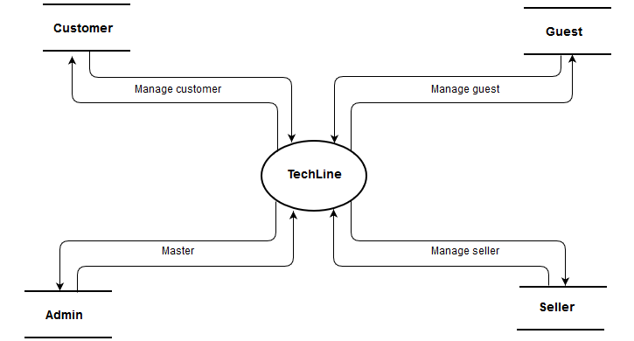

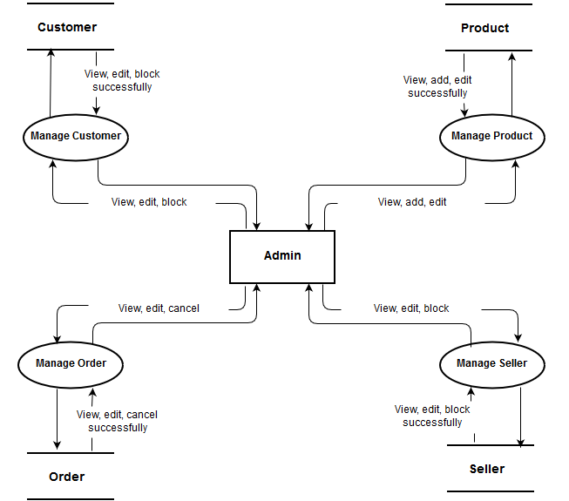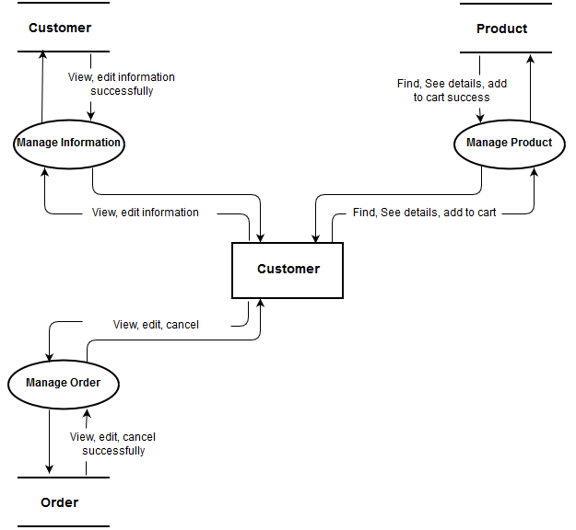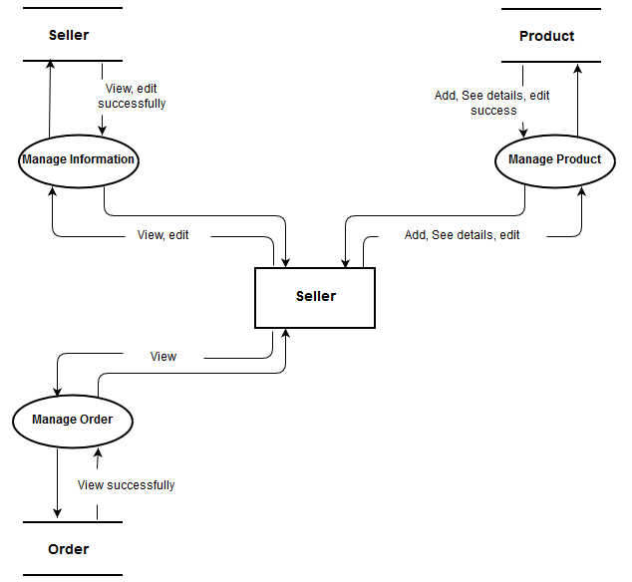

1. **USE CASE**

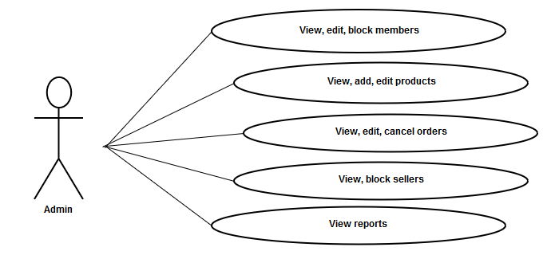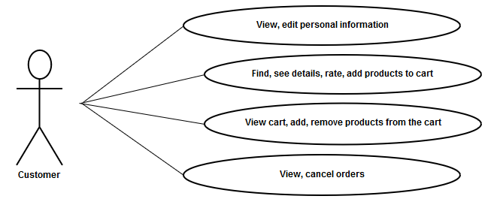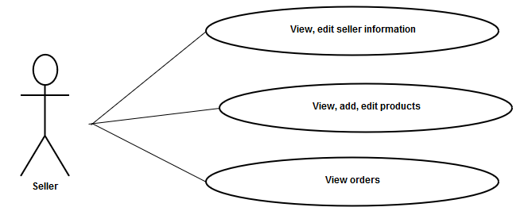

1. **SEQUENCE DIAGRAM**
   1. **Register**

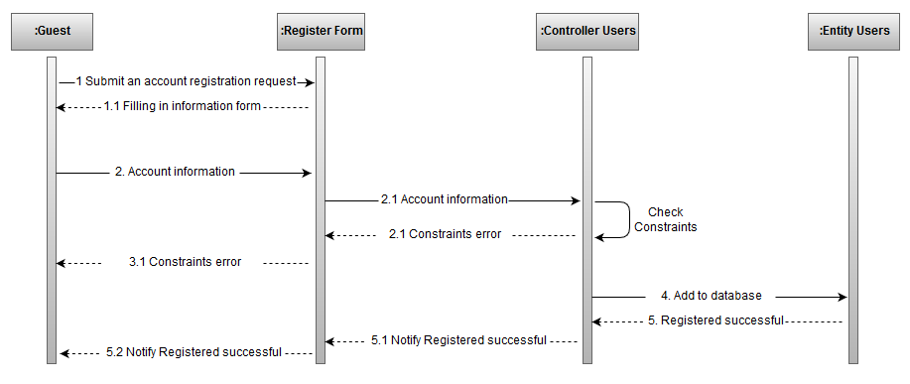

* 1. **Login**

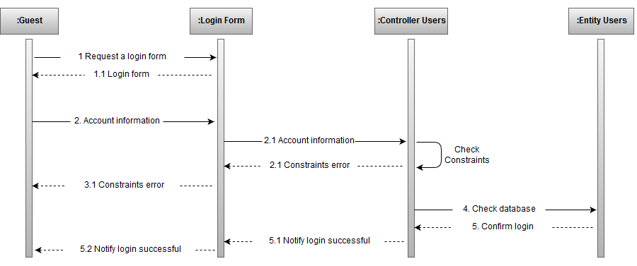

* 1. **Add New**

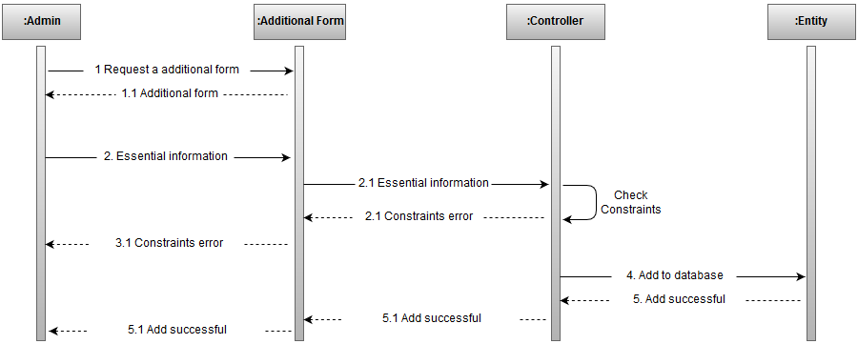

* 1. **Update**

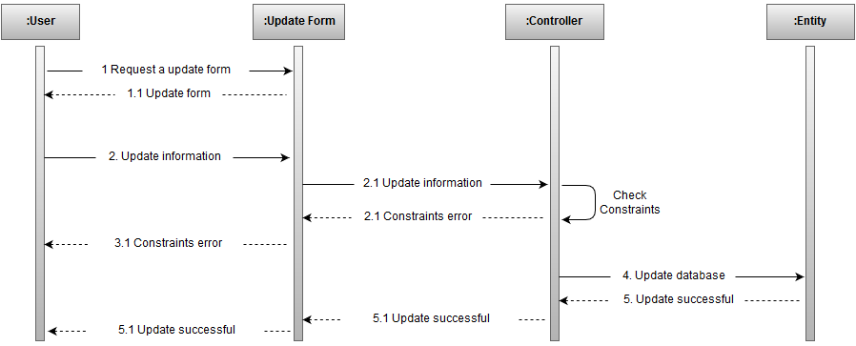

* 1. **Search**

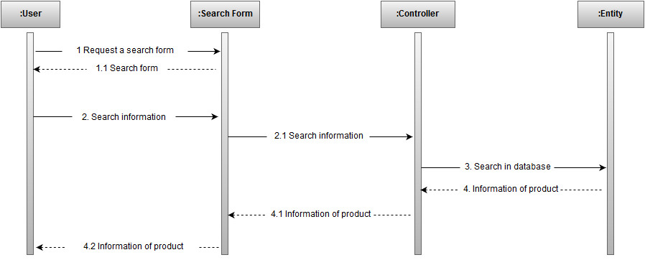

* 1. **Add to cart**

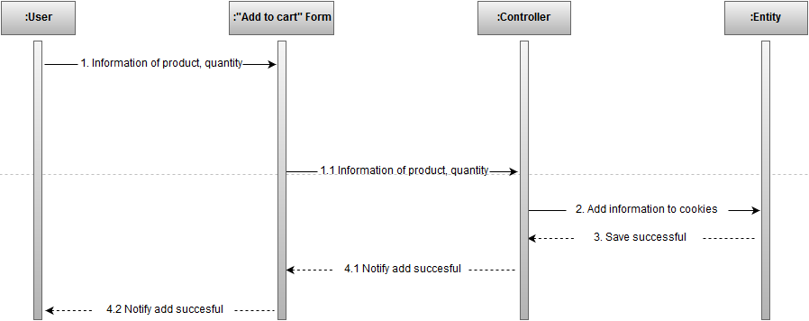

1. **ENTITY RELATIONSHIP DIAGRAM**
   1. **ERD**

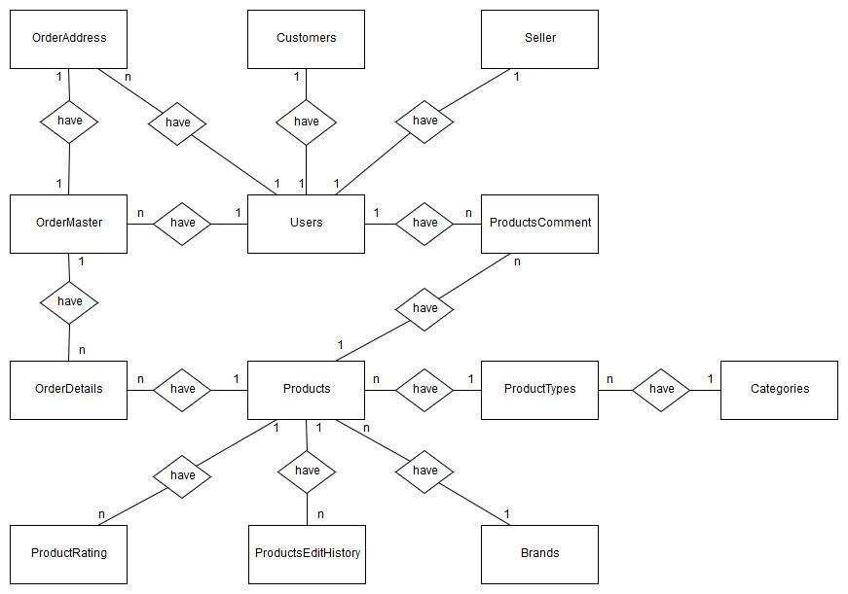

* 1. **Entity Properties**

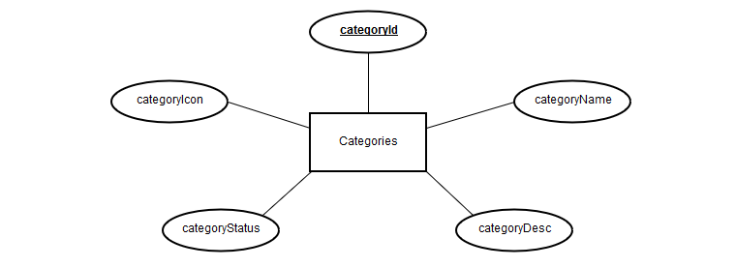

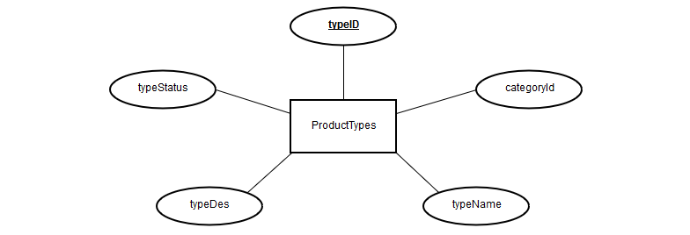

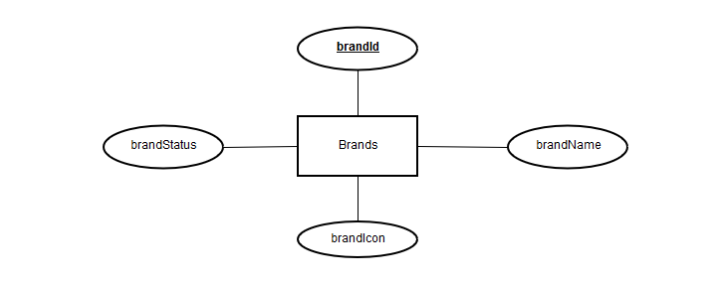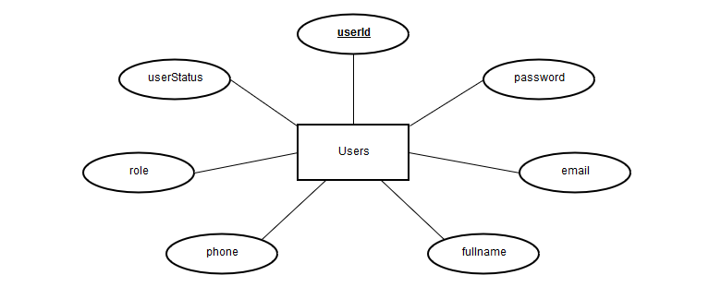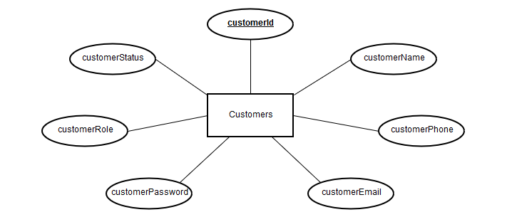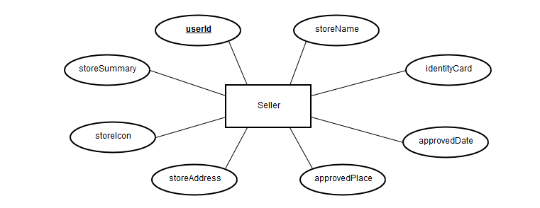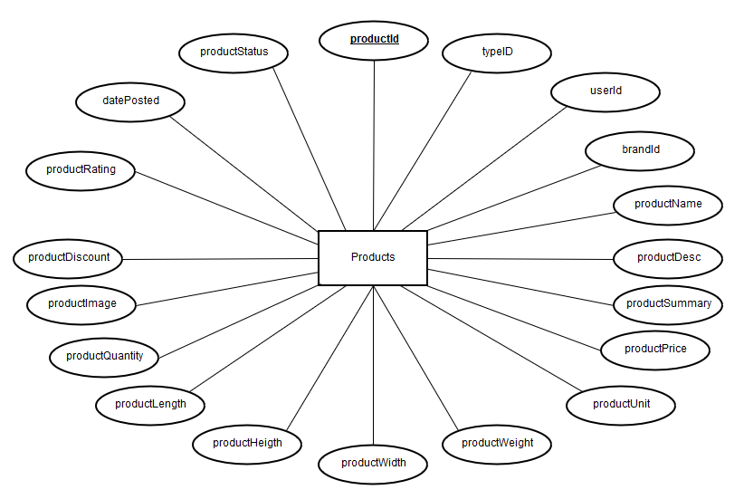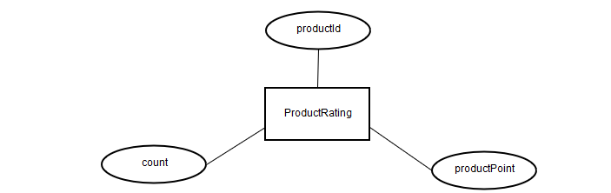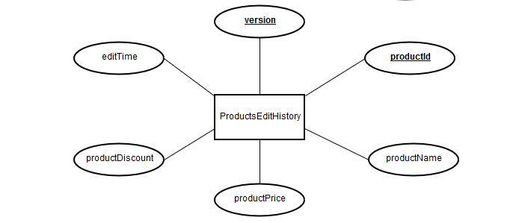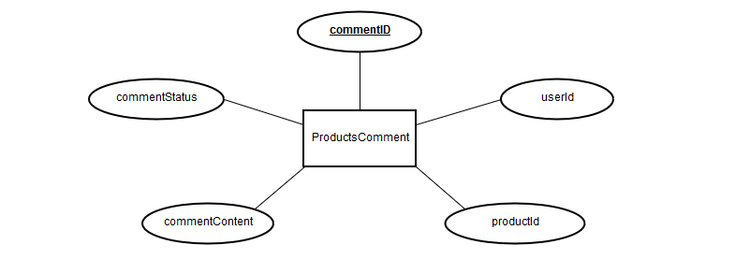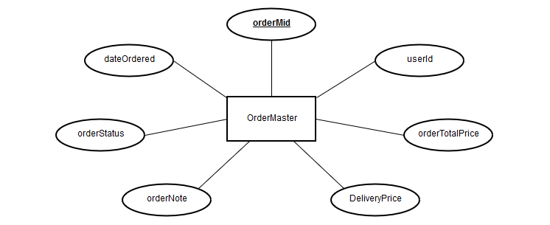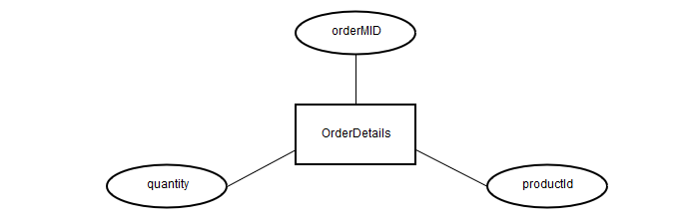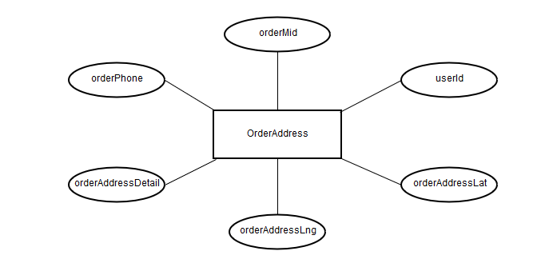

1. **TABLE DESIGN**

* **Relationship Diagram**

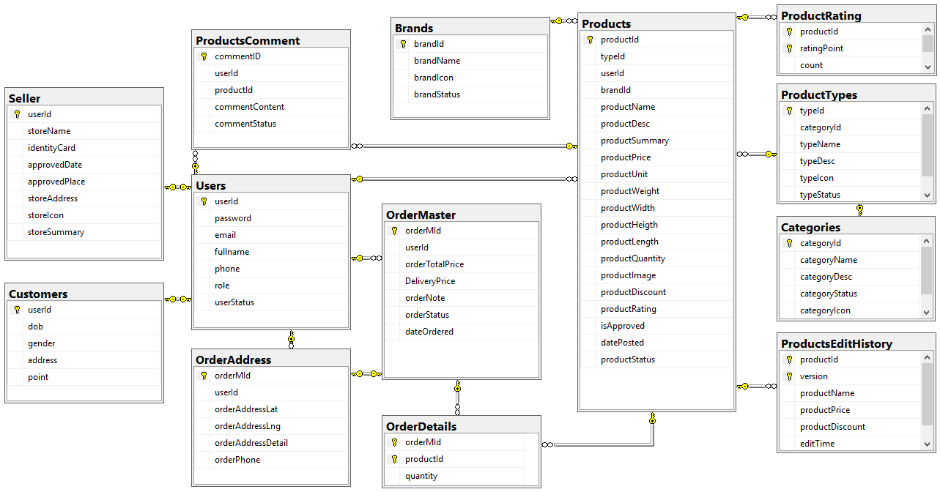

* 1. **Categories**

|  |  |  |  |  |  |
| --- | --- | --- | --- | --- | --- |
|  | Column Name | Data Type | Key | Constraint | Description |
| 1 | categoryId | varchar(10) | PK | Not null | Category Id |
| 2 | categoryName | nvarchar(100) |  |  | Category Name |
| 3 | categoryDesc | nvarchar(500) |  |  | Category Description |
| 4 | categoryStatus | bit |  |  | Category Status |
| 5 | categoryIcon | varchar(200) |  |  | Category Icon |

* 1. **ProductTypes**

|  |  |  |  |  |  |
| --- | --- | --- | --- | --- | --- |
|  | Column Name | Data Type | Key | Constraint | Description |
| 1 | typeId | varchar(10) | PK | Not null | Type Id |
| 2 | categoryId | varchar(10) | FK | Not null | Category Id |
| 3 | typeName | nvarchar(50) |  | unique | Type Name |
| 4 | typeDesc | nvarchar(300) |  |  | Type Description |
| 5 | typeIcon | varchar(200) |  |  | Type Icon |
| 6 | typeStatus | bit |  |  | Type Status |

* 1. **Brands**

|  |  |  |  |  |  |
| --- | --- | --- | --- | --- | --- |
|  | Column Name | Data Type | Key | Constraint | Description |
| 1 | brandId | varchar(10) | PK | Not null | Brand Id |
| 2 | brandName | nvarchar(100) |  |  | Brand Name |
| 3 | brandIcon | varchar(200) |  |  | Brand Icon |
| 4 | brandStatus | bit |  |  | Brand Status |

* 1. **Users**

|  |  |  |  |  |  |
| --- | --- | --- | --- | --- | --- |
|  | Column Name | Data Type | Key | Constraint | Description |
| 1 | userId | varchar(10) | PK | Not null | User Id |
| 2 | password | varchar(20) |  |  | Password |
| 3 | email | varchar(50) |  |  | Email |
| 4 | fullname | nvarchar(100) |  |  | Fullname |
| 5 | phone | varchar(20) |  |  | phone |
| 6 | role | varchar(20) |  |  | role |
| 7 | userStatus | bit |  |  | User Status |

* 1. **Customers**

|  |  |  |  |  |  |
| --- | --- | --- | --- | --- | --- |
|  | Column Name | Data Type | Key | Constraint | Description |
| 1 | userId | varchar(10) | PK, FK | Not null | User Id |
| 2 | dob | varchar(50) |  |  | Date Of Birth |
| 3 | gender | varchar(10) |  |  | Gender |
| 4 | address | nvarchar(1000) |  |  | Address |
| 5 | point | int |  |  | Membership points |

* 1. **Seller**

|  |  |  |  |  |  |
| --- | --- | --- | --- | --- | --- |
|  | Column Name | Data Type | Key | Constraint | Description |
| 1 | userId | varchar(10) | PK, FK | Not null | User Id |
| 2 | storeName | nvarchar(1000) |  |  | Store Name |
| 3 | identityCard | varchar(20) |  |  | Identity Card |
| 4 | approvedDate | varchar(10) |  |  | Approved Date |
| 5 | approvedPlace | nvarchar(20) |  |  | Approved Place |
| 6 | storeAddress | nvarchar(100) |  |  | Store Address |
| 7 | storeIcon | varchar(100) |  |  | Store Icon |
| 8 | storeSummary | nvarchar(1000) |  |  | Store Summary |

* 1. **Products**

|  |  |  |  |  |  |
| --- | --- | --- | --- | --- | --- |
|  | Column Name | Data Type | Key | Constraint | Description |
|  | productId | varchar(10) | PK | Not null | Product Id |
|  | typeId | varchar(10) | FK | Not null | Product Type Id |
|  | userId | varchar(10) | FK | Not null | User Id |
|  | brandId | varchar(10) | FK | Not null | Brand Id |
|  | productName | nvarchar(500) |  |  | Product Name |
|  | productDesc | nvarchar(3500) |  |  | Product Description |
|  | productSummary | nvarchar(1000) |  |  | Product Summary |
|  | productPrice | float |  |  | Product Price |
|  | productUnit | nvarchar(50) |  |  | Product Unit |
|  | productWeight | float |  |  | Product Weight |
|  | productWidth | float |  |  | Product Width |
|  | productHeigth | float |  |  | Product Heigth |
|  | productLength | float |  |  | Product Length |
|  | productQuantity | int |  |  | Product Quantity |
|  | productImage | varchar(4000) |  |  | Product Image |
|  | productDiscount | int |  |  | Product Discount |
|  | productRating | float |  |  | Product Rating |
|  | isApproved | bit |  |  | Is Approved |
|  | datePosted | datetime |  | getdate() | Date Posted |
|  | productStatus | bit |  |  | Product Status |

* 1. **ProductRating**

|  |  |  |  |  |  |
| --- | --- | --- | --- | --- | --- |
|  | Column Name | Data Type | Key | Constraint | Description |
| 1 | productId | varchar(10) | PK, FK | Not null | Product Id |
| 2 | ratingPoint | int | PK | Not null | Rating Point |
| 3 | count | int |  |  | Count |

* 1. **ProductsHistory**

|  |  |  |  |  |  |
| --- | --- | --- | --- | --- | --- |
|  | Column Name | Data Type | Key | Constraint | Description |
| 1 | productId | varchar(10) | FK | Not null | Product Id |
| 2 | version | int |  |  | Version |
| 3 | productName | nvarchar(50) |  |  | Product Name |
| 4 | productPrice | float |  |  | Product Price |
| 5 | productDiscount | int |  |  | Product Discount |
| 6 | editTime | datetime |  | getdate() | Edit Time |

* 1. **ProductsComment**

|  |  |  |  |  |  |
| --- | --- | --- | --- | --- | --- |
|  | Column Name | Data Type | Key | Constraint | Description |
| 1 | commentID | varchar(10) | PK | Not null | Comment ID |
| 2 | userId | varchar(10) | FK | Not null | User Id |
| 3 | productId | varchar(10) | FK | Not null | Product Id |
| 4 | commentContent | nvarchar(3000) |  |  | Comment Content |
| 5 | commentStatus | bit |  |  | Comment Status |

* 1. **OrderMaster**

|  |  |  |  |  |  |
| --- | --- | --- | --- | --- | --- |
|  | Column Name | Data Type | Key | Constraint | Description |
| 1 | orderMId | varchar(10) | PK | Not null | Order MID |
| 2 | userId | varchar(10) | FK | Not null | User Id |
| 3 | orderTotalPrice | float |  |  | Order Total Price |
| 4 | deliveryPrice | float |  |  | Delivery Price |
| 5 | orderNote | nvarchar(1000) |  |  | Order Note |
| 6 | orderStatus | varchar(10) |  |  | Order Status |
| 7 | dateOrdered | datetime |  | getdate() | Date Ordered |

* 1. **OrderDetails**

|  |  |  |  |  |  |
| --- | --- | --- | --- | --- | --- |
|  | Column Name | Data Type | Key | Constraint | Description |
| 1 | **orderMId** | varchar(10) | PK, FK | Not null | Order MID |
| 2 | productId | nvarchar(100) | PK, FK | Not null | Product Id |
| 3 | quantity | nvarchar(500) |  |  | Quantity |

* 1. **OrderAddress**

|  |  |  |  |  |  |
| --- | --- | --- | --- | --- | --- |
|  | Column Name | Data Type | Key | Constraint | Description |
| 1 | **orderMId** | varchar(10) | PK, FK | Not null | Order MID |
| 2 | userId | varchar(10) | FK | Not null | User Id |
| 3 | orderAddressLat | float |  |  | Latitude |
| 4 | orderAddressLng | float |  |  | Longitude |
| 5 | orderAddressDetail | nvarchar(1000) |  |  | Order Address Detail |
| 6 | orderPhone | varchar(20) |  |  | Order Phone |

1. **CLASS DIAGRAM**
2. **FLOW CHART**
   1. **User**

* **Registration**

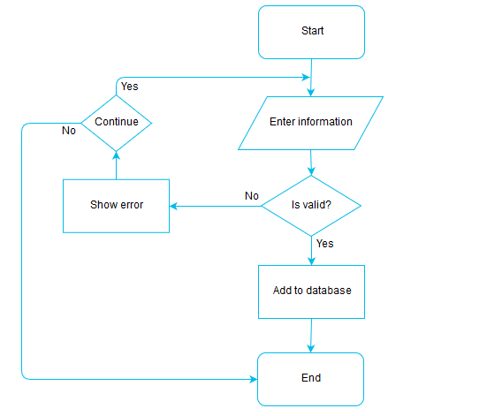

* **Login**

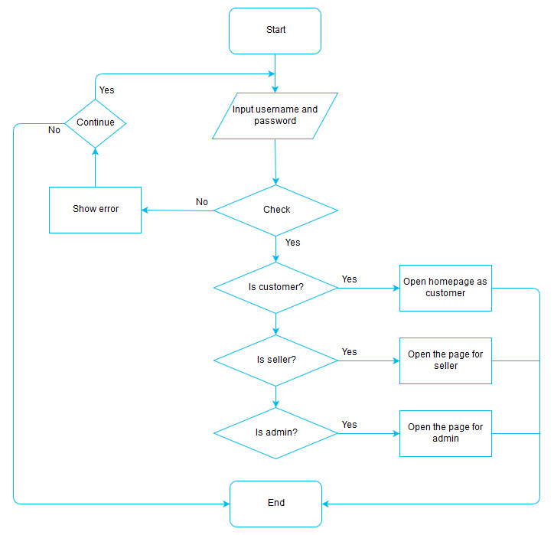

* **Updating Information**

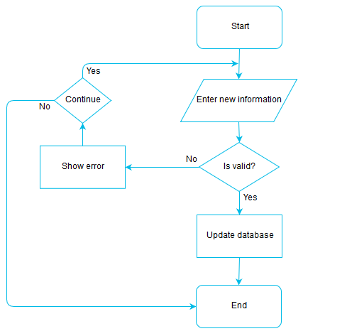

* 1. **Managing Product**
* **Add New Product**



* **Update Product Information**



* **Search Product**

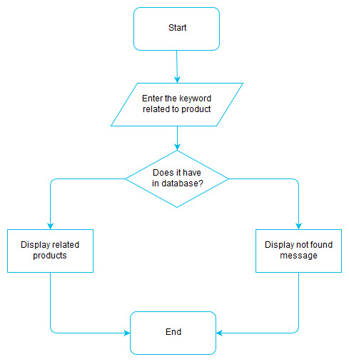

* 1. **Orders**
* **Add Order**

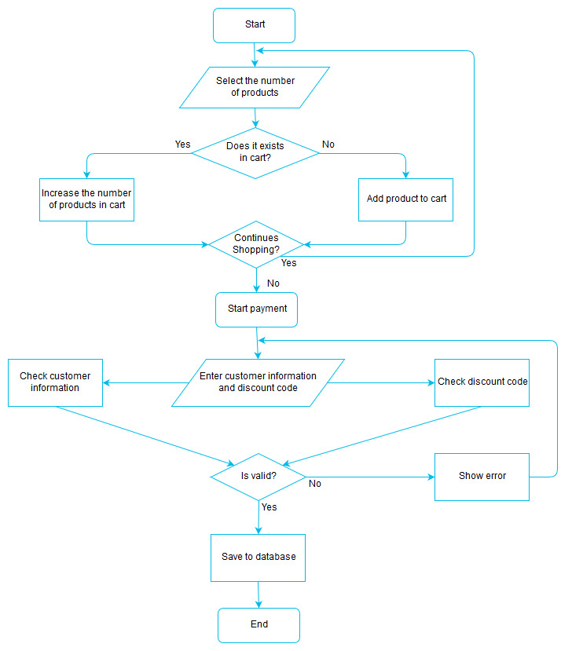

* **Edit Order**

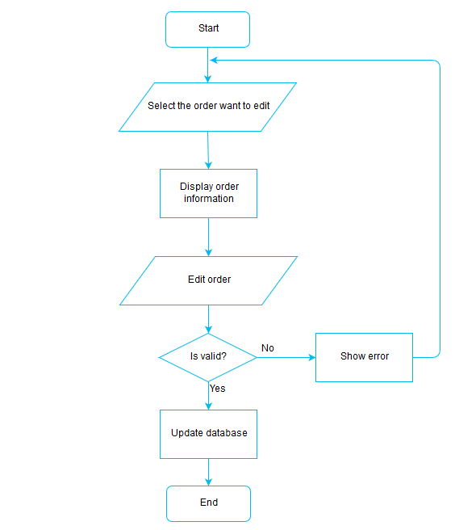

1. **REVIEW II TASKSHEET**

|  |  |  |  |  |  |  |
| --- | --- | --- | --- | --- | --- | --- |
| No. | Member | Content | Plan | Implementing period | | |
| Start date | Real start | Real day | Status |
| 1 | Nguyễn Thế Huân | Data Flow Diagram  + Use Case | 08/12/2017 | 15/12/2017 | 7 | OK |
| 2 | Nguyễn Minh Tiến | Sequence Diagram | 08/12/2017 | 15/12/2017 | 7 | OK |
| 3 | Cung Đình Uy | ERD  Table Design | 08/12/2017 | 15/12/2017 | 7 | OK |
| 4 | Trần Khánh Vương | Flow Chart | 08/12/2017 | 15/12/2017 | 7 | OK |

**REVIEW III**

* **Sitemap**
  1. **Admin**

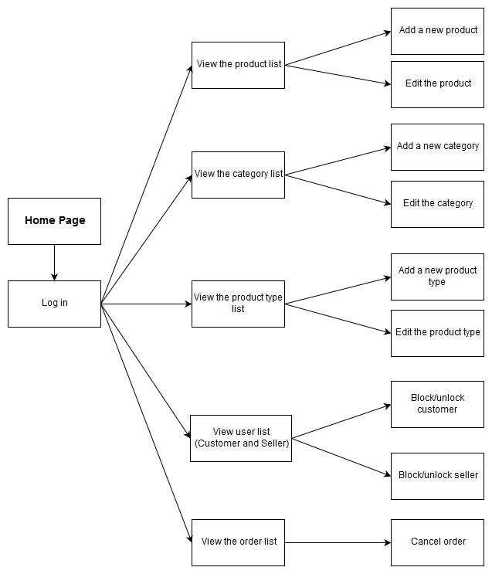

* 1. **User**

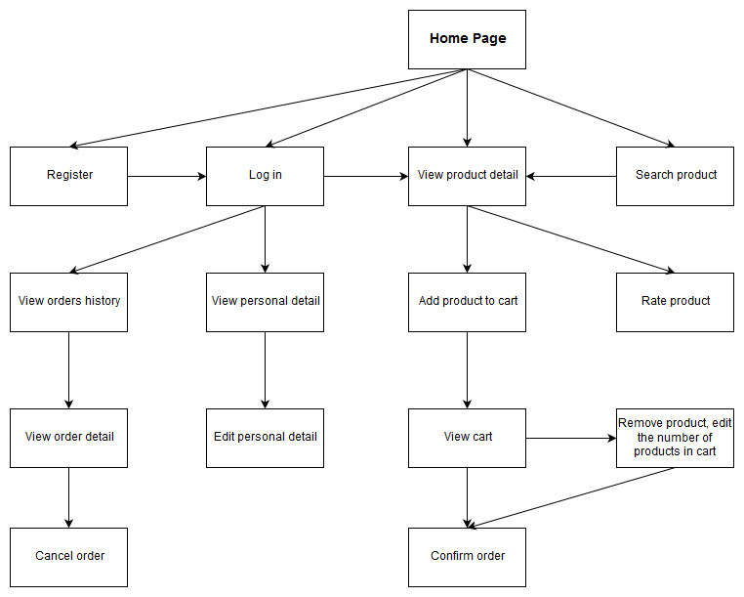

* 1. **Seller**

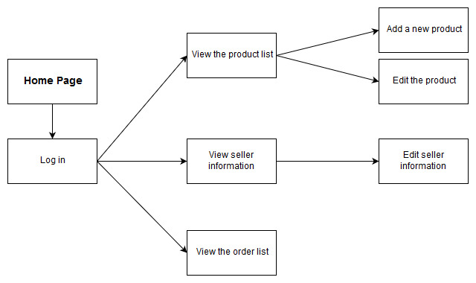

* **Screenshot**
  1. **Users**
     1. **Login**

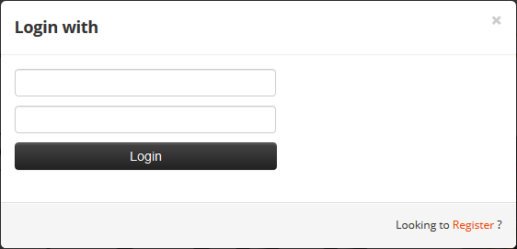

* + ***Description:***
* Link: home.jsp
* This is page user use to login.
* After login, redirect to Homepage.
  + ***Validation:***
* Username have 4-30 characters, no special characters.
* Password have 5-20 characters
  + 1. **Register**

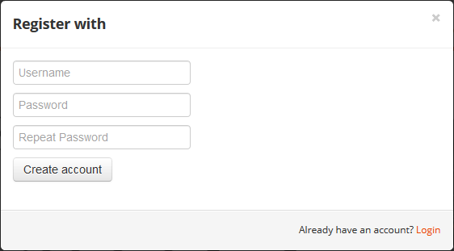

* + ***Description:***
* Link: home.jsp
* This is page user use to register an account.
* Link : redirect to Login dialog.
  + ***Validation:***
* Username have 4-30 characters, no special characters.
* Password have 5-20 characters.
* Repeat password must be the same with password
  + 1. **Manage Account**

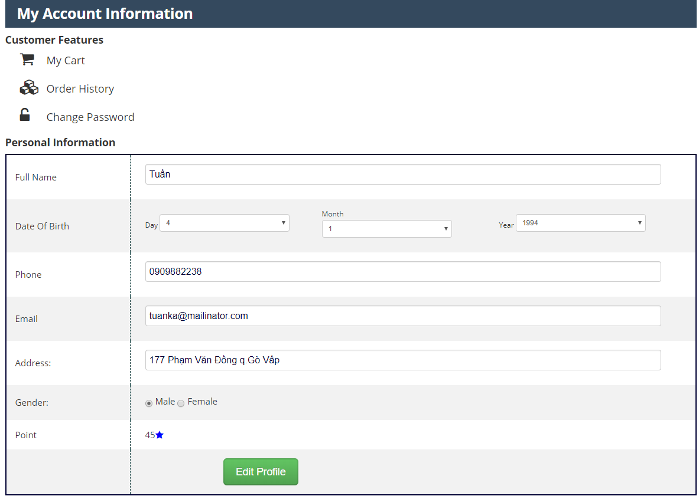

* + ***Description:***
* This is page user use to manage their account.
  + ***Validation:***
* Full name must have 1 characters or more.
* Phone have 9-15 digits.
* Email must be valid format.
* Address have 1-1000 characters.
  + 1. **Update Password**

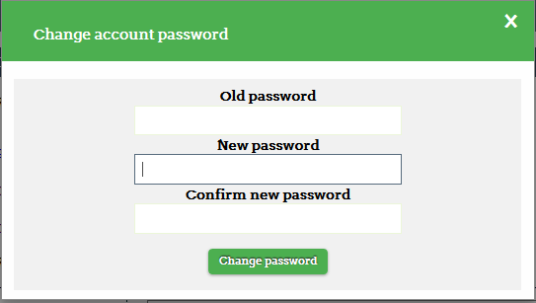

* + ***Description:***
* This is page user use to update password
  + ***Validation:***
* Old password and New password have 5-20 characters.
* Confirm password must be the same with New password.
  + 1. **Manage Order**
       1. **Order List**

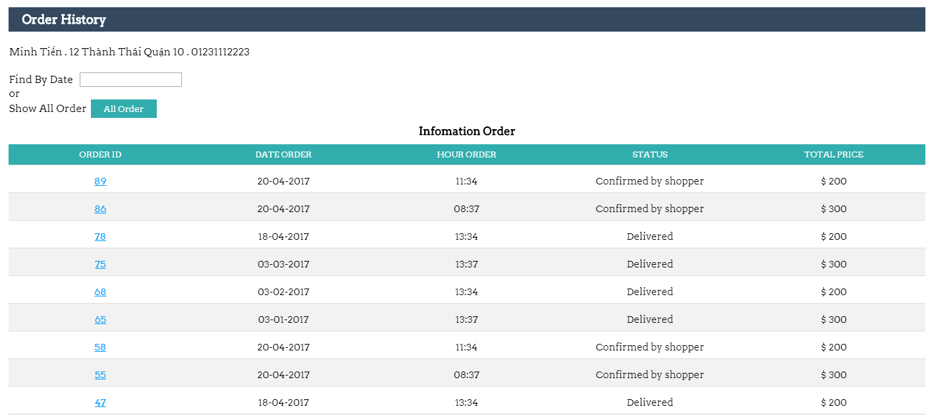

* + ***Description:***
* This is page user use to view orders list.
* User can view order history.
* User can click to “order id” to view order detail.
  + - 1. **Order Details**

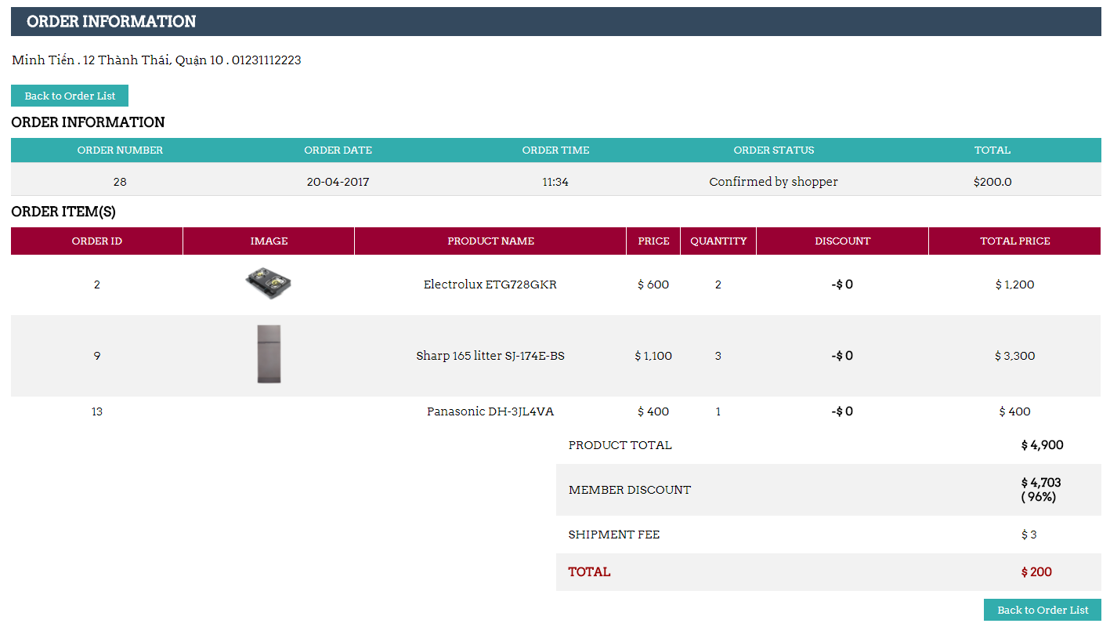

* + ***Description:***
* This is page user use to view and cancel order.
* User can view order detail.
* User can cancel order.
  + - 1. **Order Delivery**

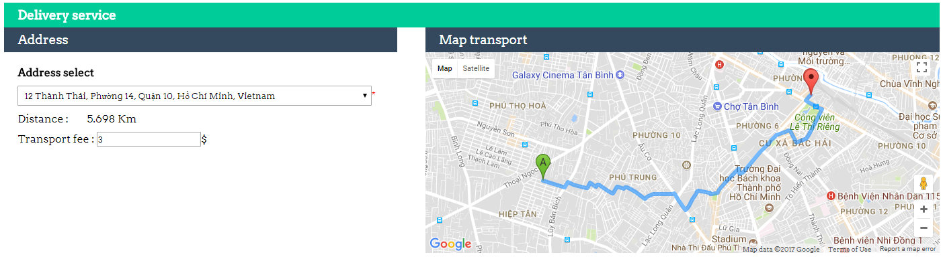

* + ***Description:***
* This is page user use to view delivery route and fee.
* User can view delievery route through google map and fee.
  + 1. **HomePage**

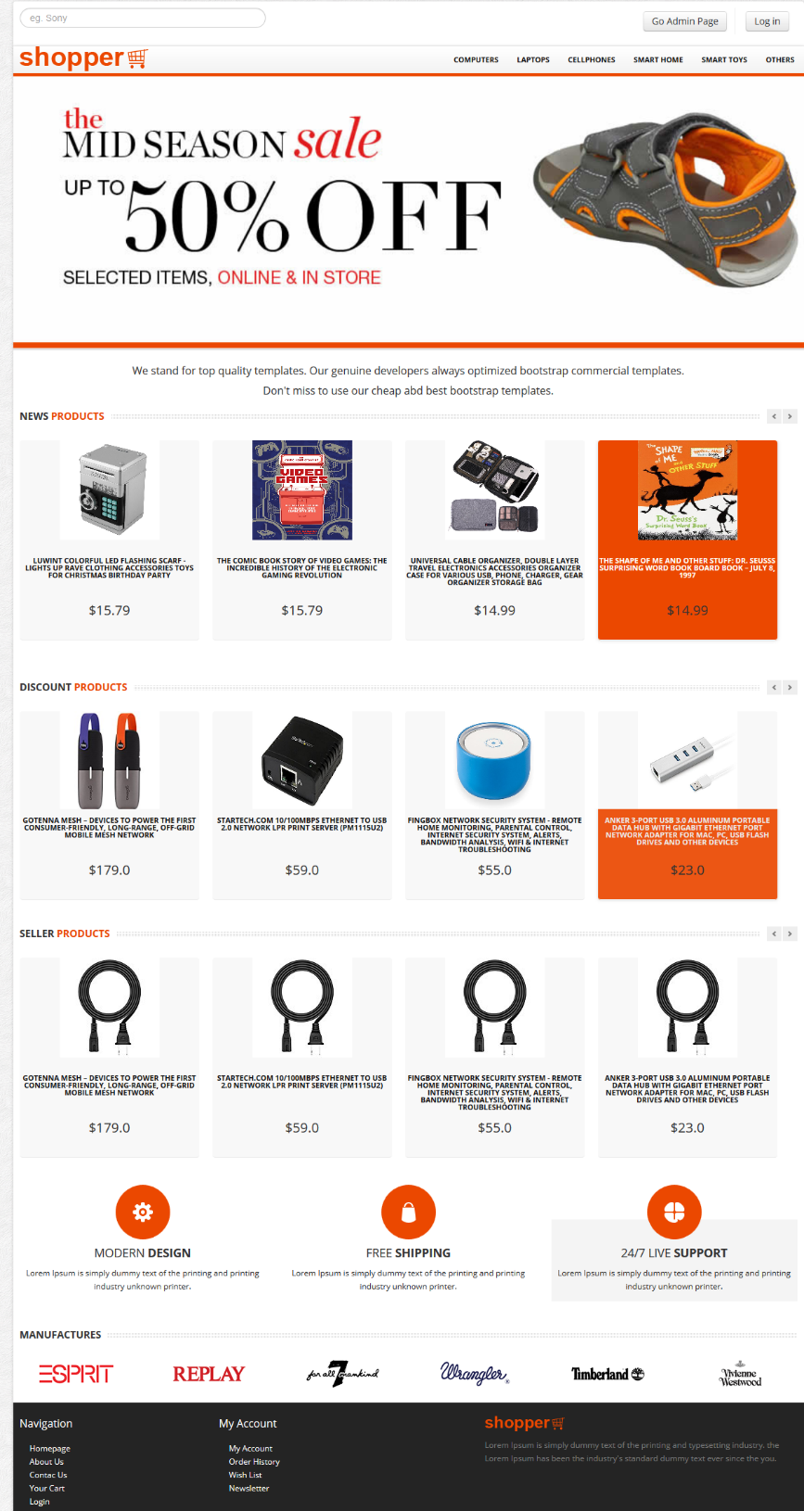

* + ***Description:***
* This page is default page when guest visit website and the page appear when user is logged in.
* User can view product, category.
* User can click product to view product detail.
  + 1. **Search Product**

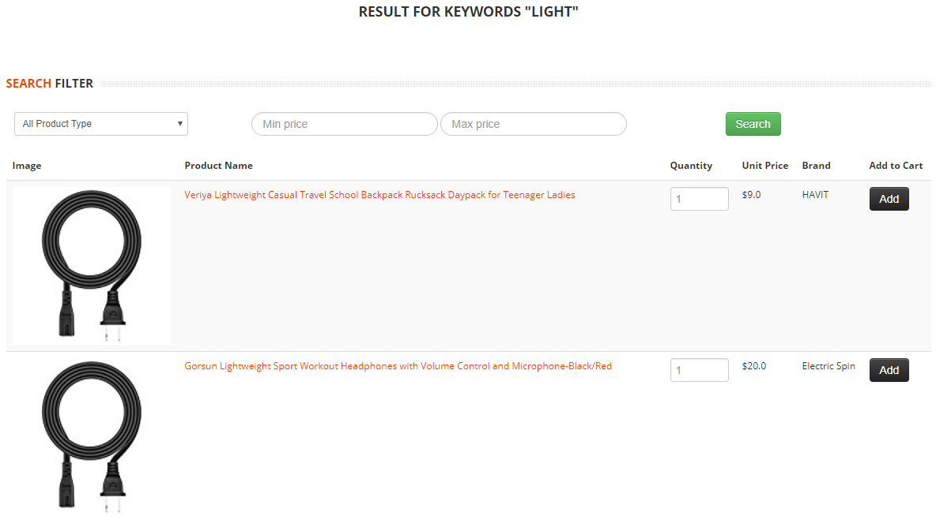

* + ***Description:***
* This page used for searching product.
* When users type keywords related to products into the search box and enter, this page appears.
  + ***Validation:***
* Min must be greater or equal 0.
* Max must be greater min and 0.01.
  + 1. **View Product Detail**

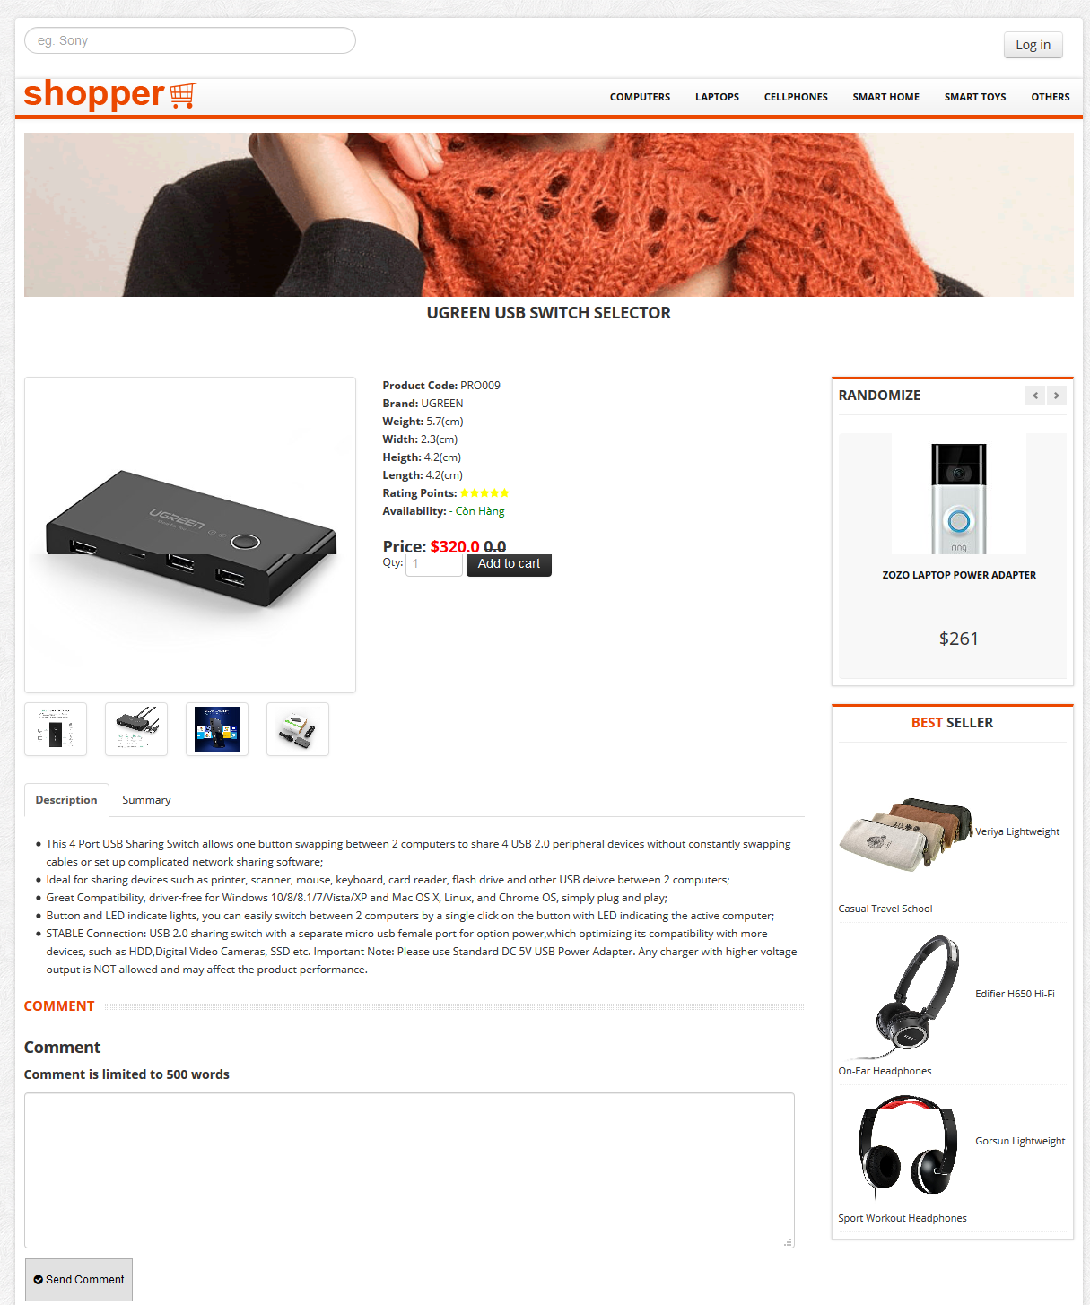

* + ***Description:***
* This page is the page to view product detail.
* User can view product detail.
* User can click “Add to cart” button to add product to cart.
* User can comment and rate product.
  + 1. **View Cart**

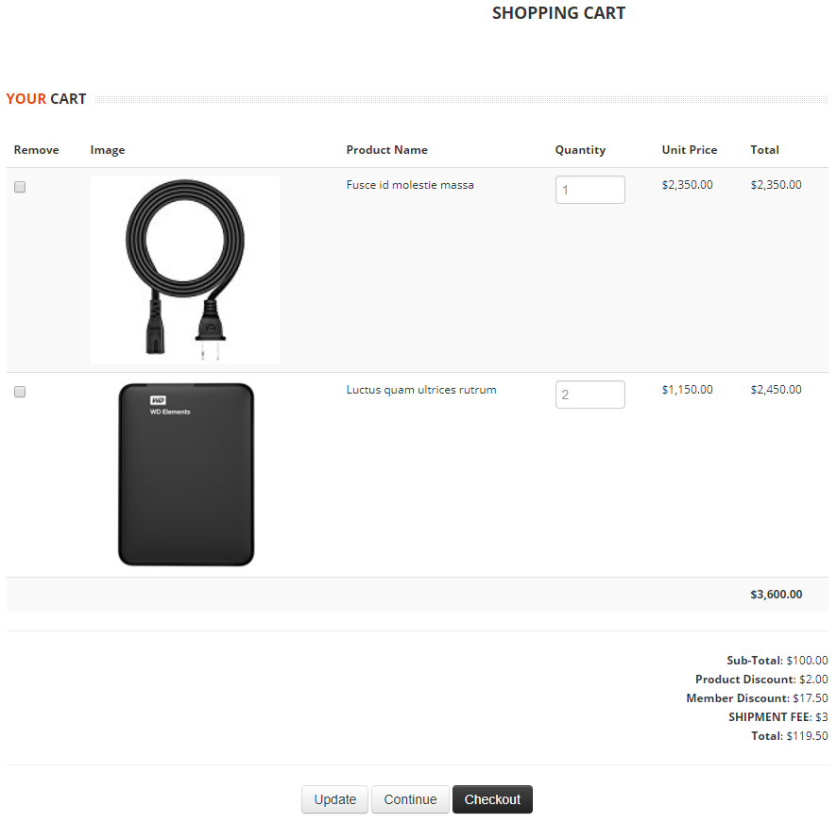

* + ***Description:***
* This page is used for checkout.
* User can view order detail.
* User can edit the number of each product in cart.
* User can remove product from cart
* User can confirm this order. After confirming, successful order notification appears.

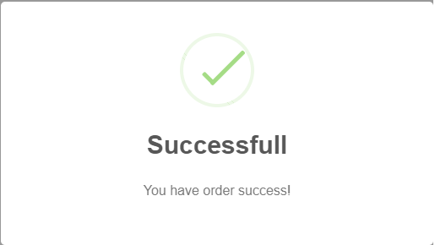

* 1. **Admin**
     1. **Manage User**

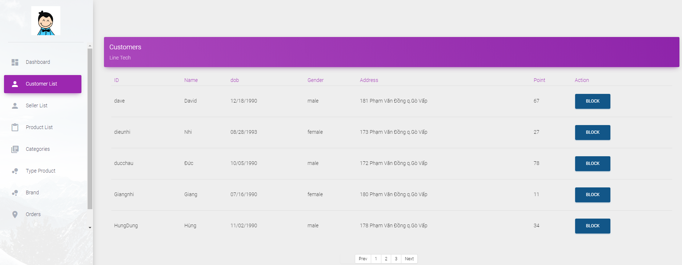

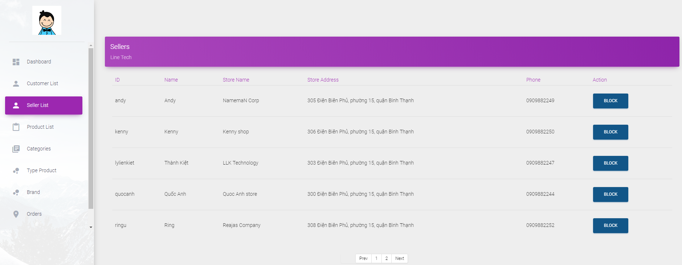

* + ***Description:***

- This is the page admin use to manage customers and sellers account.

* Admin can view customers/sellers information.
* Admin can block/unlock customers/sellers account.
  + - * 1. **Manage Product**
        2. **View , change product status**

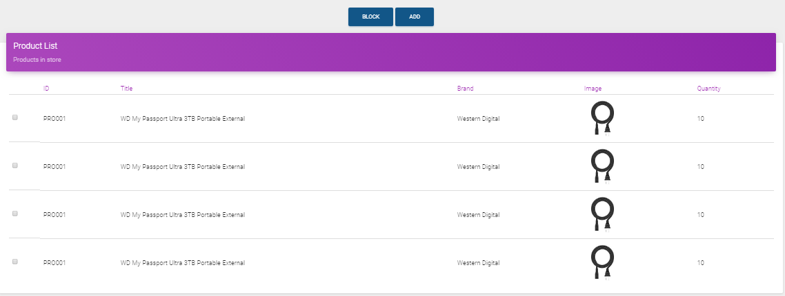

* + ***Description:***
* Link: admin/product.jsp
* This is the page admin use to manage product.
* Admin can view product information.
* Admin can block/unlock product.
  + ***Validation:***
* Unblock product: If Type/Brand of product is blocked, can not unblock product. Admin must unblock or change Type/Brand before unblock product.
  + - 1. **Add a new product**

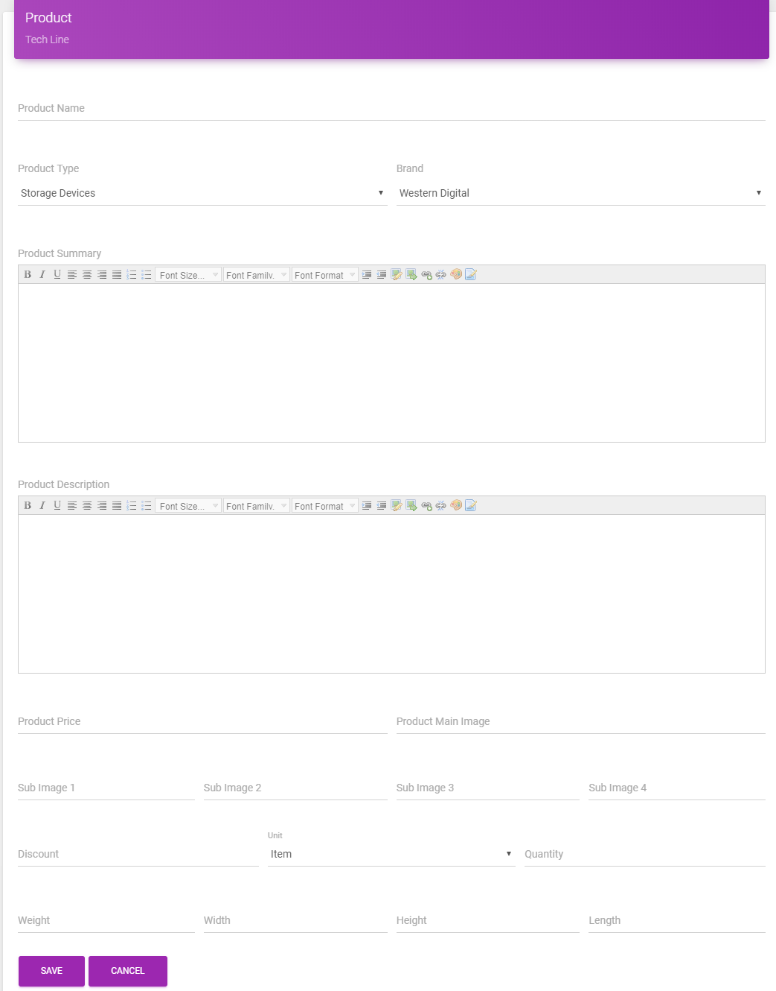

* + ***Description:***
* Link: admin/addProduct.jsp
* This is page admin use to add a new product.
* Weight unit is kilogram
* Width, height, length unit is centimeter.
  + ***Validation:***
* Product name have 1-500 characters.
* Product Type, Brand selected from the list.
* Product Sumary can not be empty.
* Product Discount must be a number, from 0 to 100. (%)
* Price must be decimal number, min 0.01 and max 10000.
* Main Image URL required.
* Quantity required, min 0 and max 100.
* Weight required, min 0.01 and max 500.
* Width, height, length required, min 0.01 and max 1000.
  + - 1. **Update product**

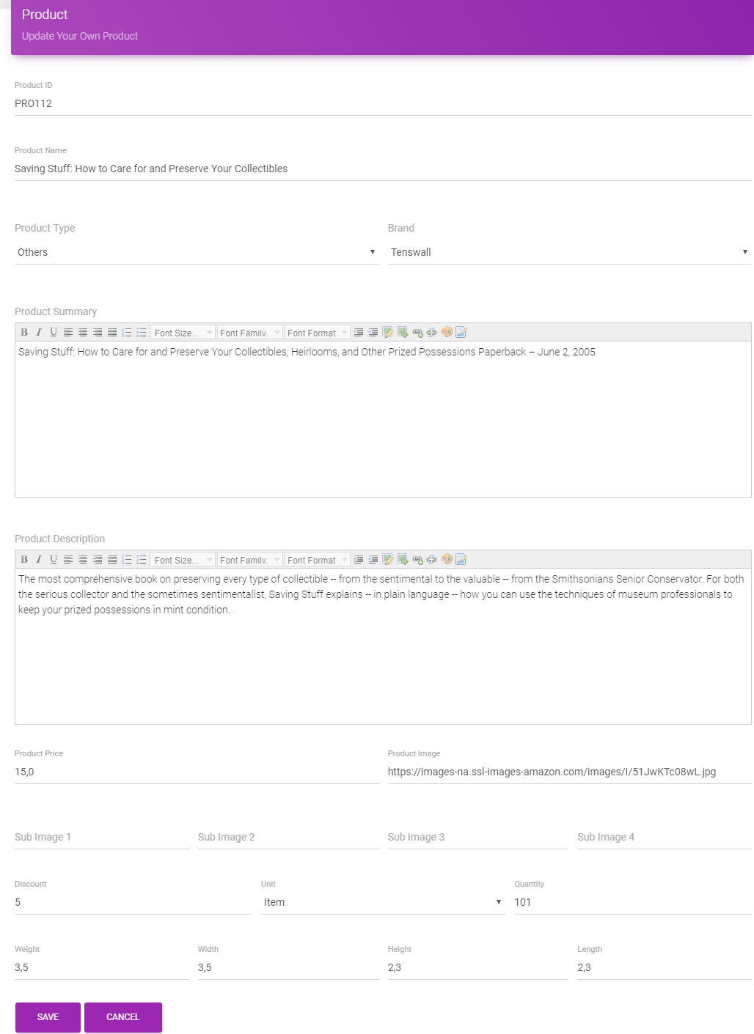

* + ***Description:***
* Link: admin/updateProduct.jsp
* This is page admin use to update product.
  + ***Validation:***
* Product name have 1-500 characters.
* Product Type, Brand selected from the list.
* Product Sumary can not be empty.
* Product Discount must be a number, from 0 to 100. (%)
* Price must be decimal number, min 0.01 and max 10000.
* Main Image URL required.
* Quantity required, min 0 and max 100.
* Weight required, min 0.01 and max 500.
* Width, height, length required, min 0.01 and max 1000.
* **Manage Category**
  1. **View, change category status**

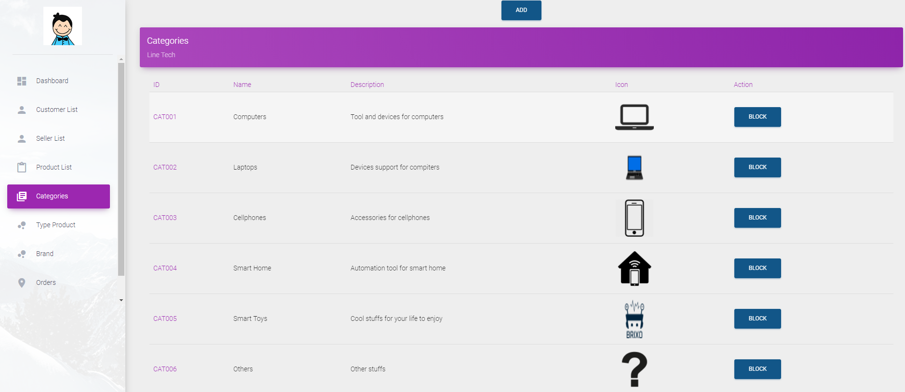

* + ***Description:***
* Link: admin/categories.jsp
* This is the page admin use to manage category.
* Admin can view category list.
* Admin can block/unlock category.
  + ***Validation:***
* Block type: If category have any product which is active, cannot block category.
* **Add a new category**

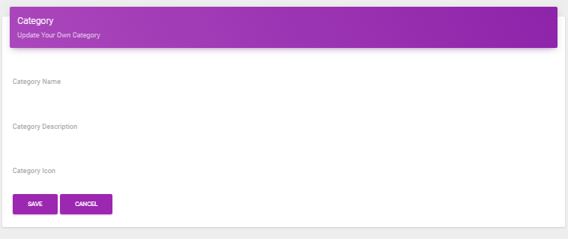

* + ***Description:***

1. Link: admin/addCategory.jsp
2. This is page admin use to add a new category.
   * ***Validation:***
3. Category name have 1-100 characters.

* **Update category**

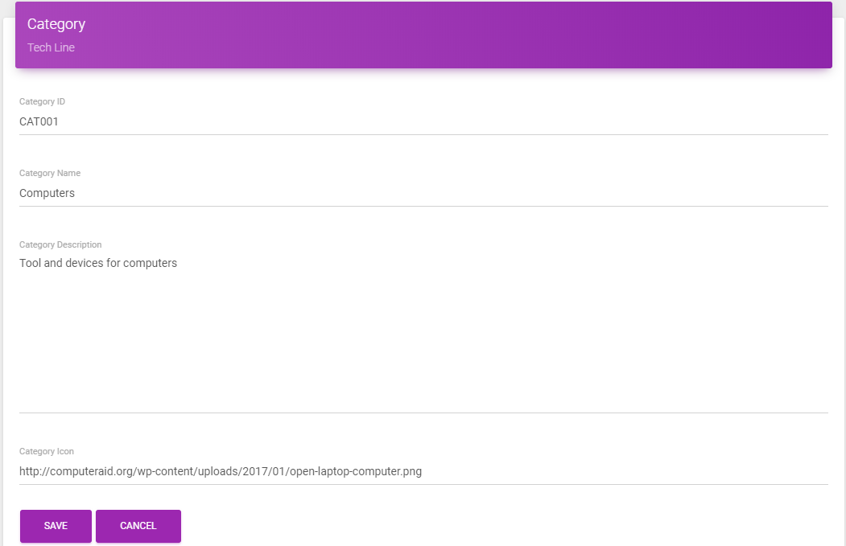

* + ***Description:***
* Link: admin/updateCategory.jsp
* This is page admin use to update category.
  + ***Validation:***
* Category name have 1-100 characters.

1. **Manage Product Type**
   1. **View, change product type status**

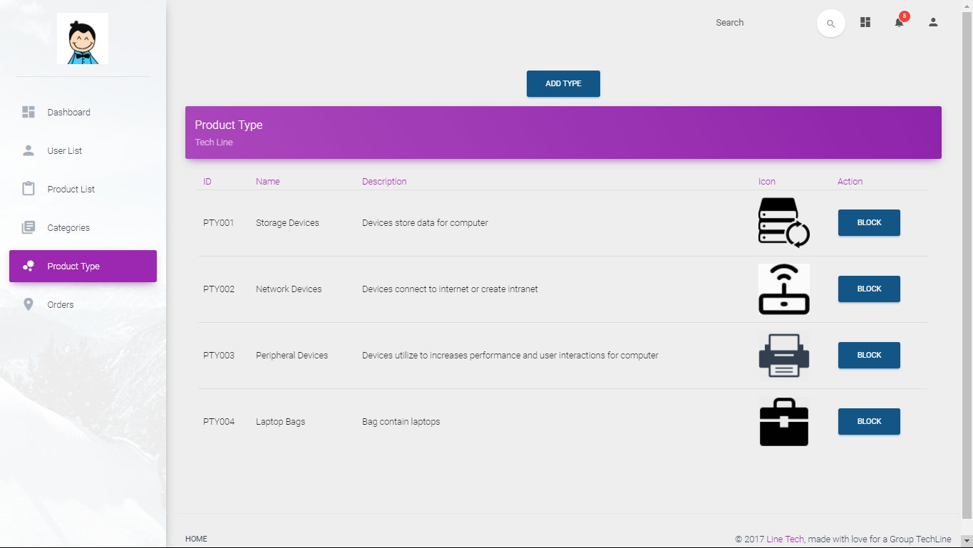

* + ***Description:***
* Link: admin/type.jsp
* This is the page admin use to manage product type.
* Admin can view product type list.
* Admin can block/unlock product type.
  + ***Validation***

1. Block type: If type have any product which is active, cannot block type.
2. Unblock type: If category of type is blocked, cannot unblock type, admin must unblock category or change category before unblock type.
   1. **Add a new product type**

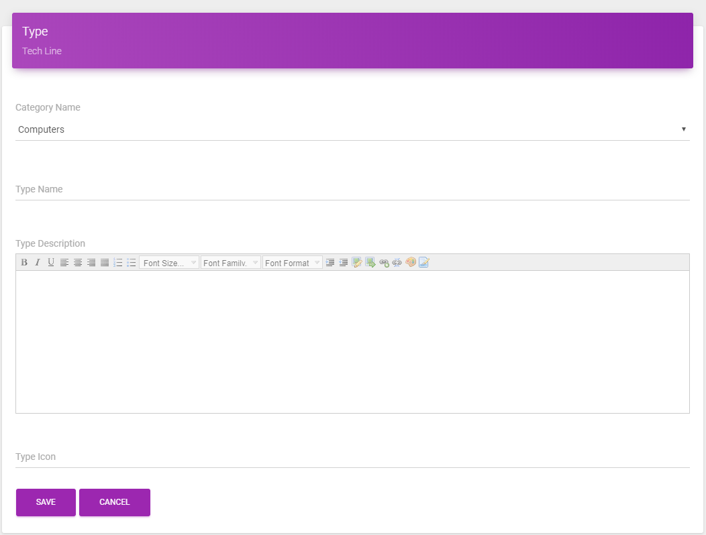

* + ***Description:***
* Link: admin/addType.jsp
* This is page admin use to add a new product type.
  + ***Validation:***
* Type name have 1-100 characters.

1. **Update product type**

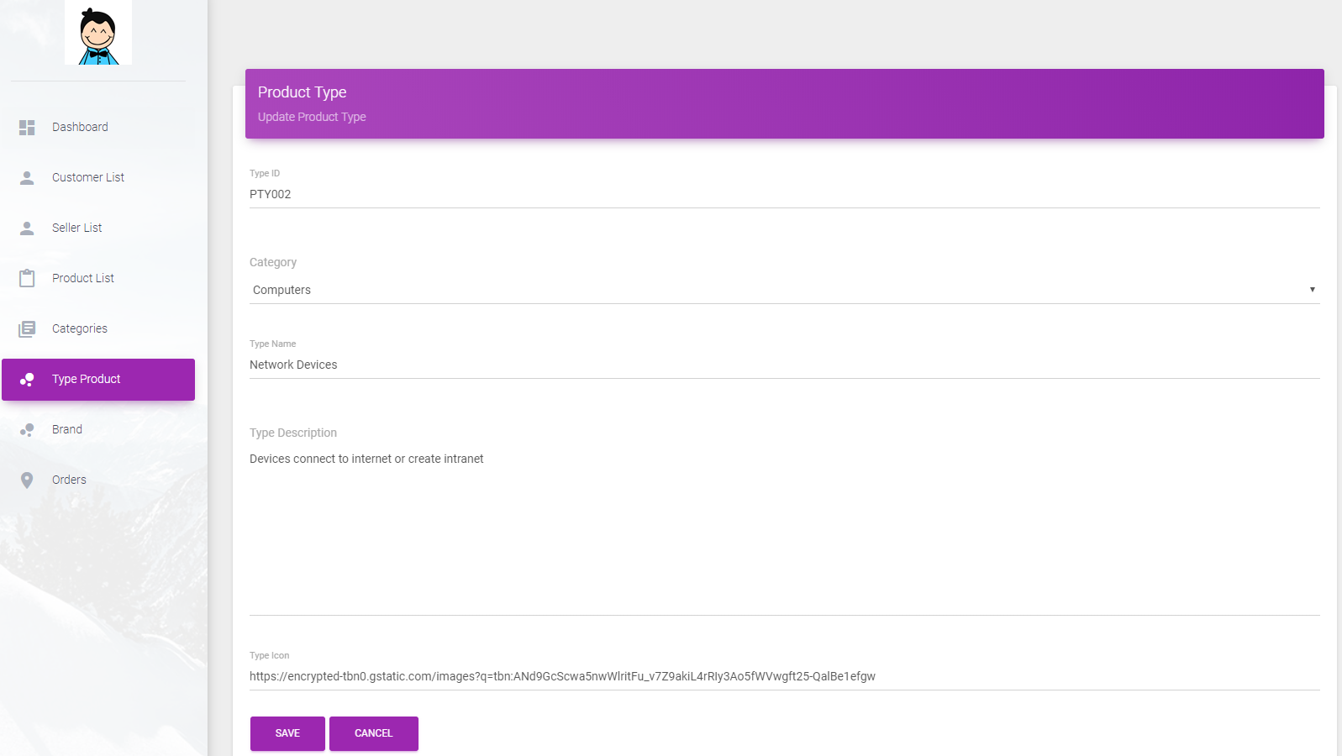

* + ***Description:***
* Link: updateCategory.jsp
* This is page admin use to update category.
  + ***Validation:***
* Type name have 1-100 characters.

1. **Manage Brand**

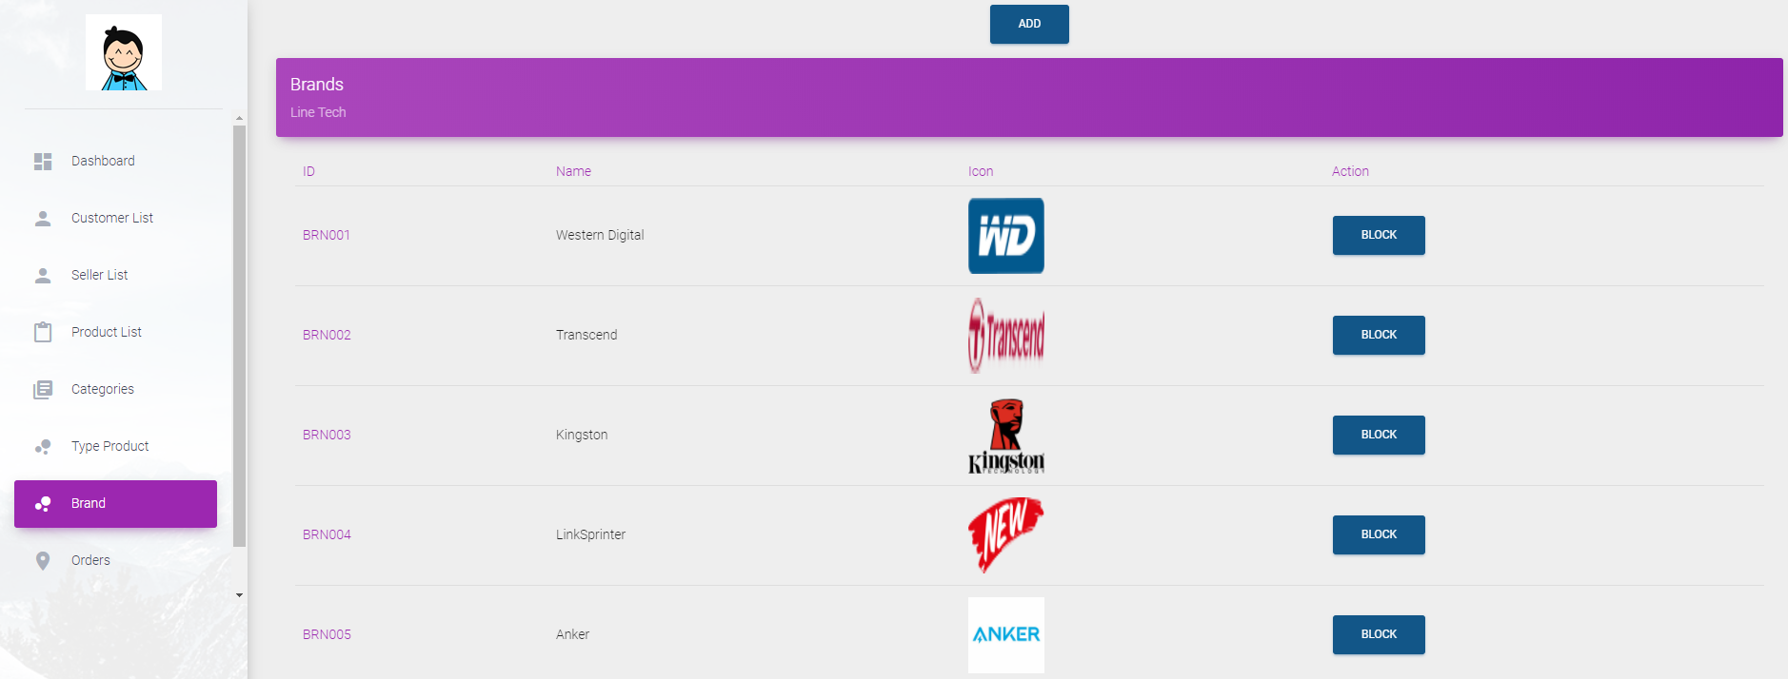

* + ***Description:***
* Link: admin/brand.jsp
* This is the page admin use to manage brand.
* Admin can view product brand list.
* Admin can block/unlock brand.
  + ***Validation***
* Block type: If type have any product which is active, can not block brand.
  + 1. **Manage Order**

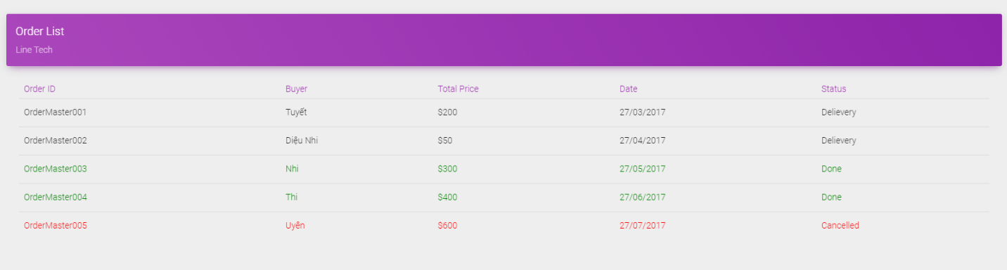

* + ***Description:***
* Link: admin/order.jsp
* This is page admin use to manage order.
* Admin can view order list.
* Admin can cancel order.
  + 1. **Report Product**

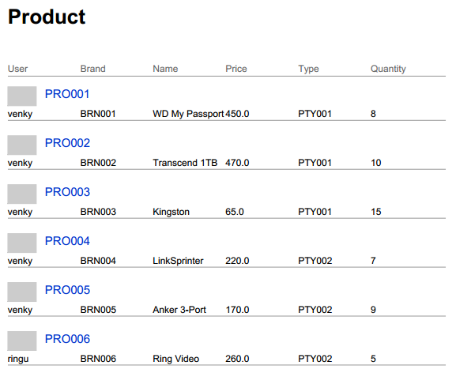

* + ***Description:***
* Link: admin/report.jsp
* This is page admin use to create a jasper report.
* Admin can view report about all products.
  + 1. **Report User**

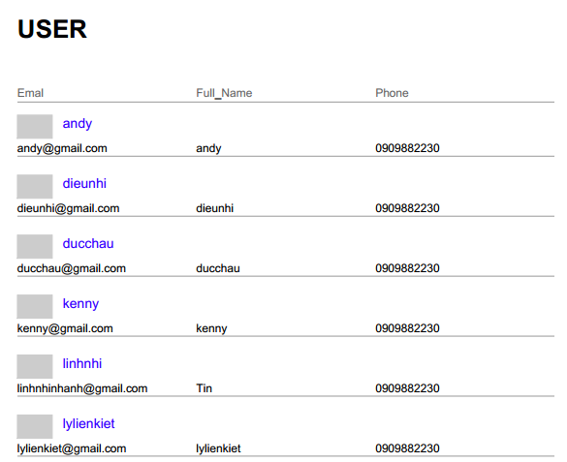

* + ***Description:***
* Link: admin/report.jsp
* This is page admin use to create a jasper report.
* Admin can view report about all users.
  + 1. **Report Order**

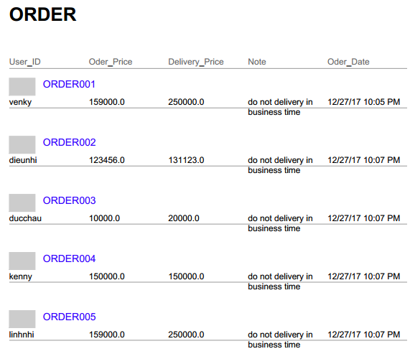

* + ***Description:***
* Link: admin/report.jsp
* This is page admin use to create a jasper report.
* Admin can view report about all order been placed.
  1. **Seller**
     1. **Manage Seller Information**

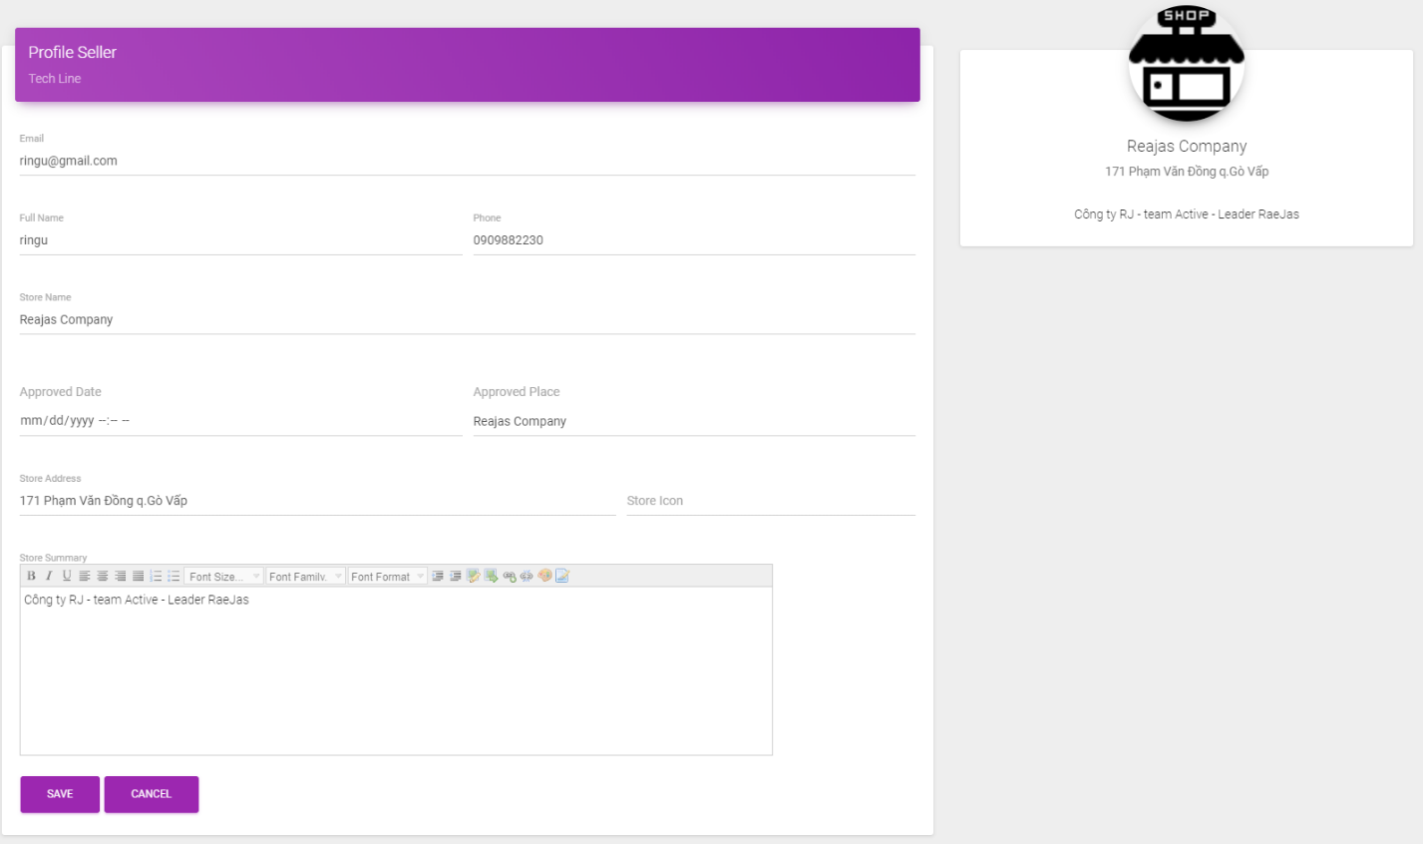

* + ***Description:***
* Link: seller/myAccount.jsp
* This is page seller use to manage their account.
  + ***Validation:***
* Full name, Store name cannot be empty.
* Phone have 10-11 digits.
* Email must be valid format.
* Address have 20 characters or more.

1. **Manage Product**
   * + 1. **View , change product status**



* + ***Description:***
* Link: seller/product.jsp
* This is the page seller use to manage their product.
* Seller can view product information.
* Seller can change product status.
  + - 1. **Add a new product**



* + ***Description:***
* Link: seller/addProduct.jsp
* This is page seller use to add a new product.
  + ***Validation:***
* Product name have 1-500 characters.
* Product Type, Brand selected from the list.
* Product Sumary can not be empty.
* Product Discount must be a number, from 0 to 100. (%)
* Price must be decimal number, min 0.01 and max 10000.
* Main Image URL required.
* Quantity required, min 0 and max 100.
* Weight required, min 0.01 and max 500.
* Width, height, length required, min 0.01 and max 1000.
  + - 1. **Update product**



* + ***Description:***
* Link: seller/updateProduct.jsp
* This is page seller use to update product.
  + ***Validation:***
* Product name have 1-500 characters.
* Product Type, Brand selected from the list.
* Product Sumary can not be empty.
* Product Discount must be a number, from 0 to 100. (%)
* Price must be decimal number, min 0.01 and max 10000.
* Main Image URL required.
* Quantity required, min 0 and max 100.
* Weight required, min 0.01 and max 500.
* Width, height, length required, min 0.01 and max 1000.

1. **Report Product**

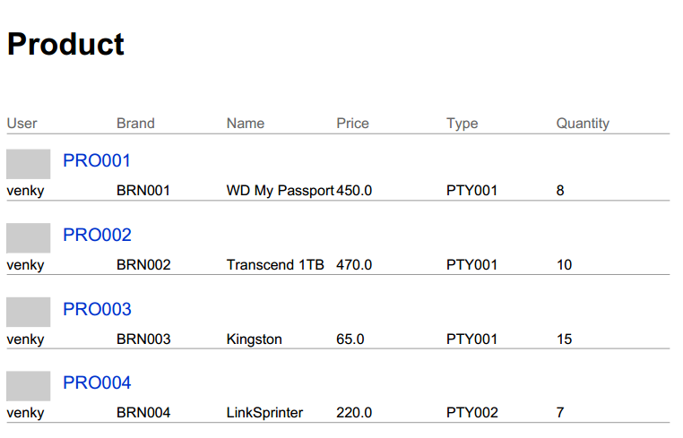

* + ***Description:***
* Link: seller/report.jsp
* This is page seller use to create a jasper report.
* Seller can view report about all products they are selling.

1. **Report Order**



* + ***Description:***
* Link: seller/report.jsp
* This is page seller use to create a jasper report.
* Seller can view report about all order they had from customers.

1. **Checklist of Validation**

|  |  |  |
| --- | --- | --- |
| **STT** | **Function** | **Check** |
|  | All numeric values default to 0 | **🗹** |
|  | Admin has all access to add and delete data | **🗹** |
|  | Data type is included in the database | **🗹** |
|  | All components are fully integrated and usable | **🗹** |
|  | All design standards have been applied | **🗹** |
|  | User interface is consistent | **🗹** |
|  | Is the flow between paths on the page accurate? | **🗹** |
|  | Have all the pages completed the error message? | **🗹** |
|  | All code run successfully | **🗹** |

1. **Submission Checklist**

|  |  |  |  |  |  |
| --- | --- | --- | --- | --- | --- |
| **STT** | **Detail** | **Yes** | **No** | **NA** | **Comment** |
|  | Are all managers able to find what they want? | Yes |  |  |  |
|  | All old data is stored and retrieved when required? | Yes |  |  |  |
|  | Are all components fully integrated and usable? | Yes |  |  |  |
|  | The user interface is no typo? | Yes |  |  |  |
|  | User-friendly application? | Yes |  |  |  |
|  | File installation project has been completed? | Yes |  |  |  |

E. **Review III Tasksheet**

|  |  |  |  |  |  |  |  |
| --- | --- | --- | --- | --- | --- | --- | --- |
| No. | Member | Content | Page | Plan | Implementing period | | |
| Start date | Real start | Real day | Status |
| 1 | Nguyễn Thế Huân | * View Product, Category and Type * Add, Edit, Remove Product in Cart * Rating , discount on products. | Index, Product Detail | 15/12/2017 | 27/12/2017 | 12 | OK |
| 2 | Nguyễn Minh Tiến | * Build google map for user to choose delivery destination. * Place an order * Manage Order * Discount on Order | Order | 15/12/2017 | 27/12/2017 | 12 | OK |
| 3 | Cung Đình Uy | * Add , Edit, Delete Product, Category , Type, Brand as Admin role * Search Product. * Create chart for admin dashboard | Admin | 15/12/2017 | 27/12/2017 | 12 | OK |
| 4 | Trần Khánh Vương | * View, Add, Edit User ‘s Information * Add, Edit, Delete Product as Seller role. * View Jasper Report | Register, Seller | 15/12/2017 | 27/12/2017 | 12 | OK |

**Instructor**

**Phan Minh Tâm**